**2.3 Logic Operators**

**Description:** Logical-and example

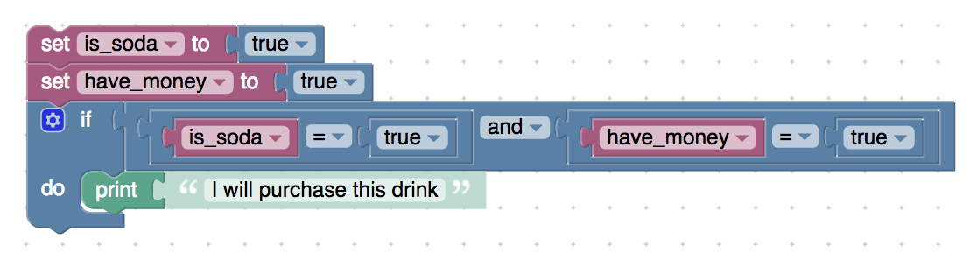  
<xml xmlns="http://www.w3.org/1999/xhtml">

 <variables>

    <variable type="" id="Ic-v}5`^/*}bEW5{tZ?r">is_soda</variable>

    <variable type="" id="u{6yjIFr/Fcbq9g6p`dL">have_money</variable>

 </variables>

 <block type="variables_set" id="jA9fb/L)~/?vMBfHytbw" x="188" y="37">

    <field name="VAR" id="Ic-v}5`^/*}bEW5{tZ?r" variabletype="">is_soda</field>

    <value name="VALUE">

     <block type="logic_boolean" id="m.Dm3(xXm4Ha%zmmVnBJ">

       <field name="BOOL">TRUE</field>

     </block>

    </value>

    <next>

     <block type="variables_set" id="2mkwq-GG}0g~m+.#|wHn">

       <field name="VAR" id="u{6yjIFr/Fcbq9g6p`dL" variabletype="">have_money</field>

       <value name="VALUE">

         <block type="logic_boolean" id="t,me}oHNYB`Tr/[*^)9J">

           <field name="BOOL">TRUE</field>

         </block>

       </value>

       <next>

         <block type="controls_if" id="_vU:GbHDNVcoh?-7^^B7">

           <value name="IF0">

             <block type="logic_operation" id="@=97Pkc69-D$?yYKgI8j">

               <field name="OP">AND</field>

               <value name="A">

                 <block type="logic_compare" id="F3Ogx0/MzLaU:ic4@kiW">

                   <field name="OP">EQ</field>

                   <value name="A">

                     <block type="variables_get" id="$|X#-zAcUc:x89EYWLaX">

                       <field name="VAR" id="Ic-v}5`^/*}bEW5{tZ?r" variabletype="">is_soda</field>

                     </block>

                   </value>

                   <value name="B">

                     <block type="logic_boolean" id="mpiNN@E(g=vg{l95h,HI">

                       <field name="BOOL">TRUE</field>

                     </block>

                   </value>

                 </block>

               </value>

               <value name="B">

                 <block type="logic_compare" id="?$cbNr4_w.(et]3CutJ)">

                   <field name="OP">EQ</field>

                   <value name="A">

                     <block type="variables_get" id="o2fEY8WBOETccqNun#d[">

                       <field name="VAR" id="u{6yjIFr/Fcbq9g6p`dL" variabletype="">have_money</field>

                     </block>

                   </value>

                   <value name="B">

                     <block type="logic_boolean" id="XT-]Mp3u!y-}H(psG0x8">

                       <field name="BOOL">TRUE</field>

                     </block>

                   </value>

                 </block>

               </value>

             </block>

           </value>

           <statement name="DO0">

             <block type="text_print" id="Y`*W)syRGRH7:_xbQaIU">

               <value name="TEXT">

                 <shadow type="text" id="N%pnetD(tasThee/TZlX">

                   <field name="TEXT">I will purchase this drink</field>

                 </shadow>

               </value>

             </block>

           </statement>

         </block>

       </next>

     </block>

    </next>

 </block>

</xml>

**Description:** Logical-and using boolean again

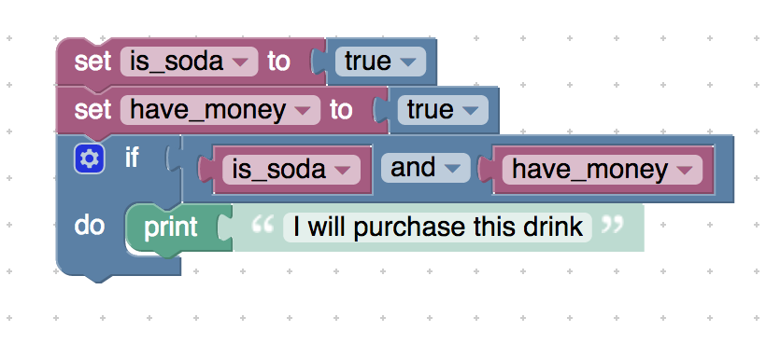

<xml xmlns="http://www.w3.org/1999/xhtml">

 <variables>

    <variable type="" id="Ic-v}5`^/*}bEW5{tZ?r">is_soda</variable>

    <variable type="" id="u{6yjIFr/Fcbq9g6p`dL">have_money</variable>

 </variables>

 <block type="variables_set" id="jA9fb/L)~/?vMBfHytbw" x="188" y="112">

    <field name="VAR" id="Ic-v}5`^/*}bEW5{tZ?r" variabletype="">is_soda</field>

    <value name="VALUE">

     <block type="logic_boolean" id="m.Dm3(xXm4Ha%zmmVnBJ">

       <field name="BOOL">TRUE</field>

     </block>

    </value>

    <next>

     <block type="variables_set" id="2mkwq-GG}0g~m+.#|wHn">

       <field name="VAR" id="u{6yjIFr/Fcbq9g6p`dL" variabletype="">have_money</field>

       <value name="VALUE">

         <block type="logic_boolean" id="t,me}oHNYB`Tr/[*^)9J">

           <field name="BOOL">TRUE</field>

         </block>

       </value>

       <next>

         <block type="controls_if" id="_vU:GbHDNVcoh?-7^^B7">

           <value name="IF0">

             <block type="logic_operation" id="@=97Pkc69-D$?yYKgI8j">

               <field name="OP">AND</field>

               <value name="A">

                 <block type="variables_get" id="1sC_8dbOU/ET3NGL1P|t">

                   <field name="VAR" id="Ic-v}5`^/*}bEW5{tZ?r" variabletype="">is_soda</field>

                 </block>

               </value>

               <value name="B">

                 <block type="variables_get" id="B#DFgt/,?Jp1pT`31ymx">

                   <field name="VAR" id="u{6yjIFr/Fcbq9g6p`dL" variabletype="">have_money</field>

                 </block>

               </value>

             </block>

           </value>

           <statement name="DO0">

             <block type="text_print" id="Y`*W)syRGRH7:_xbQaIU">

               <value name="TEXT">

                 <shadow type="text" id="N%pnetD(tasThee/TZlX">

                   <field name="TEXT">I will purchase this drink</field>

                 </shadow>

               </value>

             </block>

           </statement>

         </block>

       </next>

     </block>

    </next>

 </block>

</xml>

**Description:** An example to show that True and false gives false

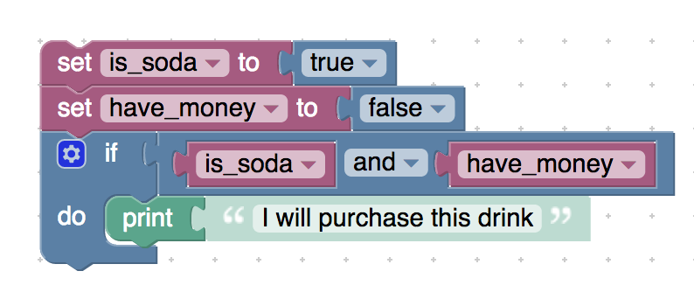

<xml xmlns="http://www.w3.org/1999/xhtml">

 <variables>

    <variable type="" id="Ic-v}5`^/*}bEW5{tZ?r">is_soda</variable>

    <variable type="" id="u{6yjIFr/Fcbq9g6p`dL">have_money</variable>

 </variables>

 <block type="variables_set" id="jA9fb/L)~/?vMBfHytbw" x="188" y="112">

    <field name="VAR" id="Ic-v}5`^/*}bEW5{tZ?r" variabletype="">is_soda</field>

    <value name="VALUE">

     <block type="logic_boolean" id="m.Dm3(xXm4Ha%zmmVnBJ">

       <field name="BOOL">TRUE</field>

     </block>

    </value>

    <next>

     <block type="variables_set" id="2mkwq-GG}0g~m+.#|wHn">

       <field name="VAR" id="u{6yjIFr/Fcbq9g6p`dL" variabletype="">have_money</field>

       <value name="VALUE">

         <block type="logic_boolean" id="t,me}oHNYB`Tr/[*^)9J">

           <field name="BOOL">FALSE</field>

         </block>

       </value>

       <next>

         <block type="controls_if" id="_vU:GbHDNVcoh?-7^^B7">

           <value name="IF0">

             <block type="logic_operation" id="@=97Pkc69-D$?yYKgI8j">

               <field name="OP">AND</field>

               <value name="A">

                 <block type="variables_get" id="1sC_8dbOU/ET3NGL1P|t">

                   <field name="VAR" id="Ic-v}5`^/*}bEW5{tZ?r" variabletype="">is_soda</field>

                 </block>

               </value>

               <value name="B">

                 <block type="variables_get" id="B#DFgt/,?Jp1pT`31ymx">

                   <field name="VAR" id="u{6yjIFr/Fcbq9g6p`dL" variabletype="">have_money</field>

                 </block>

               </value>

             </block>

           </value>

           <statement name="DO0">

             <block type="text_print" id="Y`*W)syRGRH7:_xbQaIU">

               <value name="TEXT">

                 <shadow type="text" id="N%pnetD(tasThee/TZlX">

                   <field name="TEXT">I will purchase this drink</field>

                 </shadow>

               </value>

             </block>

           </statement>

         </block>

       </next>

     </block>

    </next>

 </block>

</xml>

* **Description:** Multiple ands in 1 if statement (a and b and c)

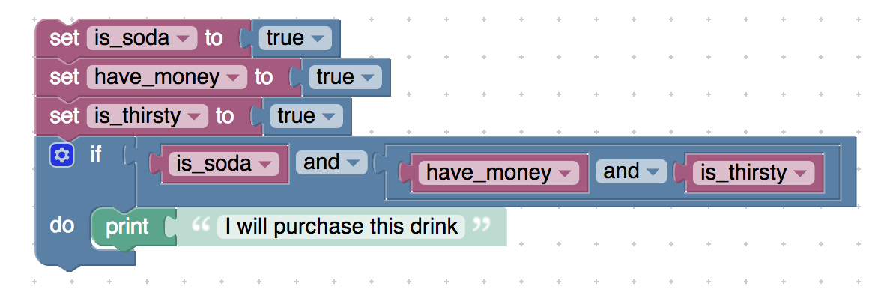

<xml xmlns="http://www.w3.org/1999/xhtml">

 <variables>

    <variable type="" id="Ic-v}5`^/*}bEW5{tZ?r">is_soda</variable>

    <variable type="" id="u{6yjIFr/Fcbq9g6p`dL">have_money</variable>

    <variable type="" id="=fQS:%G$T$;orv2KKvf8">is_thirsty</variable>

 </variables>

 <block type="variables_set" id="jA9fb/L)~/?vMBfHytbw" x="188" y="112">

    <field name="VAR" id="Ic-v}5`^/*}bEW5{tZ?r" variabletype="">is_soda</field>

    <value name="VALUE">

     <block type="logic_boolean" id="m.Dm3(xXm4Ha%zmmVnBJ">

       <field name="BOOL">TRUE</field>

     </block>

    </value>

    <next>

     <block type="variables_set" id="2mkwq-GG}0g~m+.#|wHn">

       <field name="VAR" id="u{6yjIFr/Fcbq9g6p`dL" variabletype="">have_money</field>

       <value name="VALUE">

         <block type="logic_boolean" id="t,me}oHNYB`Tr/[*^)9J">

           <field name="BOOL">TRUE</field>

         </block>

       </value>

       <next>

         <block type="variables_set" id="udx-YnX);p{sARvPb/XY">

           <field name="VAR" id="=fQS:%G$T$;orv2KKvf8" variabletype="">is_thirsty</field>

           <value name="VALUE">

             <block type="logic_boolean" id="J1OUSqSIRQ$5j(?exvRG">

               <field name="BOOL">TRUE</field>

             </block>

           </value>

           <next>

             <block type="controls_if" id="_vU:GbHDNVcoh?-7^^B7">

               <value name="IF0">

                 <block type="logic_operation" id="@=97Pkc69-D$?yYKgI8j">

                   <field name="OP">AND</field>

                   <value name="A">

                     <block type="variables_get" id="1sC_8dbOU/ET3NGL1P|t">

                       <field name="VAR" id="Ic-v}5`^/*}bEW5{tZ?r" variabletype="">is_soda</field>

                     </block>

                   </value>

                   <value name="B">

                     <block type="logic_operation" id="KEZ_GX+!VC$?+3H+x#v;">

                       <field name="OP">AND</field>

                       <value name="A">

                         <block type="variables_get" id="B#DFgt/,?Jp1pT`31ymx">

                           <field name="VAR" id="u{6yjIFr/Fcbq9g6p`dL" variabletype="">have_money</field>

                         </block>

                       </value>

                       <value name="B">

                         <block type="variables_get" id="1h_a4))NG+KRTP75_;G!">

                           <field name="VAR" id="=fQS:%G$T$;orv2KKvf8" variabletype="">is_thirsty</field>

                         </block>

                       </value>

                     </block>

                   </value>

                 </block>

               </value>

               <statement name="DO0">

                 <block type="text_print" id="Y`*W)syRGRH7:_xbQaIU">

                   <value name="TEXT">

                     <shadow type="text" id="N%pnetD(tasThee/TZlX">

                       <field name="TEXT">I will purchase this drink</field>

                     </shadow>

                   </value>

                 </block>

               </statement>

             </block>

           </next>

         </block>

       </next>

     </block>

    </next>

 </block>

</xml>

**Description:** An example to show that “True and True and False” is False

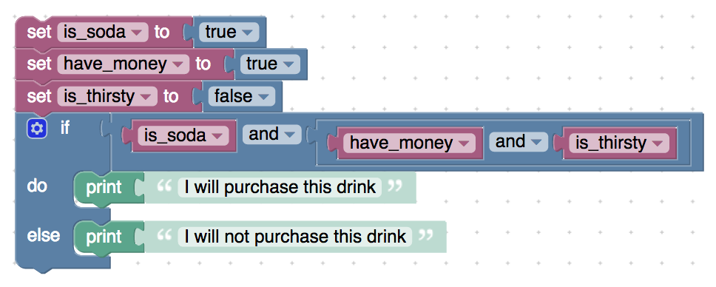

<xml xmlns="http://www.w3.org/1999/xhtml">

 <variables>

    <variable type="" id="Ic-v}5`^/*}bEW5{tZ?r">is_soda</variable>

    <variable type="" id="u{6yjIFr/Fcbq9g6p`dL">have_money</variable>

    <variable type="" id="=fQS:%G$T$;orv2KKvf8">is_thirsty</variable>

 </variables>

 <block type="variables_set" id="jA9fb/L)~/?vMBfHytbw" x="188" y="112">

    <field name="VAR" id="Ic-v}5`^/*}bEW5{tZ?r" variabletype="">is_soda</field>

    <value name="VALUE">

     <block type="logic_boolean" id="m.Dm3(xXm4Ha%zmmVnBJ">

       <field name="BOOL">TRUE</field>

     </block>

    </value>

    <next>

     <block type="variables_set" id="2mkwq-GG}0g~m+.#|wHn">

       <field name="VAR" id="u{6yjIFr/Fcbq9g6p`dL" variabletype="">have_money</field>

       <value name="VALUE">

         <block type="logic_boolean" id="t,me}oHNYB`Tr/[*^)9J">

           <field name="BOOL">TRUE</field>

         </block>

       </value>

       <next>

         <block type="variables_set" id="udx-YnX);p{sARvPb/XY">

           <field name="VAR" id="=fQS:%G$T$;orv2KKvf8" variabletype="">is_thirsty</field>

           <value name="VALUE">

             <block type="logic_boolean" id="J1OUSqSIRQ$5j(?exvRG">

               <field name="BOOL">FALSE</field>

             </block>

           </value>

           <next>

             <block type="controls_if" id="_vU:GbHDNVcoh?-7^^B7">

               <mutation else="1"></mutation>

               <value name="IF0">

                 <block type="logic_operation" id="@=97Pkc69-D$?yYKgI8j">

                   <field name="OP">AND</field>

                   <value name="A">

                     <block type="variables_get" id="1sC_8dbOU/ET3NGL1P|t">

                       <field name="VAR" id="Ic-v}5`^/*}bEW5{tZ?r" variabletype="">is_soda</field>

                     </block>

                   </value>

                   <value name="B">

                     <block type="logic_operation" id="KEZ_GX+!VC$?+3H+x#v;">

                       <field name="OP">AND</field>

                       <value name="A">

                         <block type="variables_get" id="B#DFgt/,?Jp1pT`31ymx">

                           <field name="VAR" id="u{6yjIFr/Fcbq9g6p`dL" variabletype="">have_money</field>

                         </block>

                       </value>

                       <value name="B">

                         <block type="variables_get" id="1h_a4))NG+KRTP75_;G!">

                           <field name="VAR" id="=fQS:%G$T$;orv2KKvf8" variabletype="">is_thirsty</field>

                         </block>

                       </value>

                     </block>

                   </value>

                 </block>

               </value>

               <statement name="DO0">

                 <block type="text_print" id="Y`*W)syRGRH7:_xbQaIU">

                   <value name="TEXT">

                     <shadow type="text" id="N%pnetD(tasThee/TZlX">

                       <field name="TEXT">I will purchase this drink</field>

                     </shadow>

                   </value>

                 </block>

               </statement>

               <statement name="ELSE">

                 <block type="text_print" id="(KVIRDl6eYZYLRh?1vi+">

                   <value name="TEXT">

                     <shadow type="text" id="qcDx2d|[,;=jkP]FBQgZ">

                       <field name="TEXT">I will not purchase this drink</field>

                     </shadow>

                   </value>

                 </block>

               </statement>

             </block>

           </next>

         </block>

       </next>

     </block>

    </next>

 </block>

</xml>

**Description:** An example of using boolean variables with nested if blocks

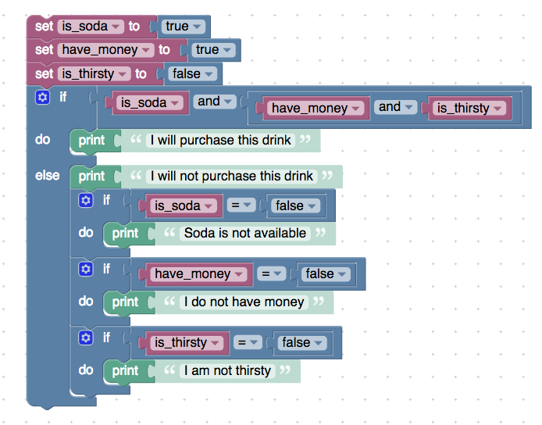

<xml xmlns="http://www.w3.org/1999/xhtml">

 <variables>

    <variable type="" id="Ic-v}5`^/*}bEW5{tZ?r">is_soda</variable>

    <variable type="" id="u{6yjIFr/Fcbq9g6p`dL">have_money</variable>

    <variable type="" id="=fQS:%G$T$;orv2KKvf8">is_thirsty</variable>

 </variables>

 <block type="variables_set" id="jA9fb/L)~/?vMBfHytbw" x="188" y="112">

    <field name="VAR" id="Ic-v}5`^/*}bEW5{tZ?r" variabletype="">is_soda</field>

    <value name="VALUE">

     <block type="logic_boolean" id="m.Dm3(xXm4Ha%zmmVnBJ">

       <field name="BOOL">TRUE</field>

     </block>

    </value>

    <next>

     <block type="variables_set" id="2mkwq-GG}0g~m+.#|wHn">

       <field name="VAR" id="u{6yjIFr/Fcbq9g6p`dL" variabletype="">have_money</field>

       <value name="VALUE">

         <block type="logic_boolean" id="t,me}oHNYB`Tr/[*^)9J">

           <field name="BOOL">TRUE</field>

         </block>

       </value>

       <next>

         <block type="variables_set" id="udx-YnX);p{sARvPb/XY">

           <field name="VAR" id="=fQS:%G$T$;orv2KKvf8" variabletype="">is_thirsty</field>

           <value name="VALUE">

             <block type="logic_boolean" id="J1OUSqSIRQ$5j(?exvRG">

               <field name="BOOL">FALSE</field>

             </block>

           </value>

           <next>

             <block type="controls_if" id="_vU:GbHDNVcoh?-7^^B7">

               <mutation else="1"></mutation>

               <value name="IF0">

                 <block type="logic_operation" id="@=97Pkc69-D$?yYKgI8j">

                   <field name="OP">AND</field>

                   <value name="A">

                     <block type="variables_get" id="1sC_8dbOU/ET3NGL1P|t">

                       <field name="VAR" id="Ic-v}5`^/*}bEW5{tZ?r" variabletype="">is_soda</field>

                     </block>

                   </value>

                   <value name="B">

                     <block type="logic_operation" id="KEZ_GX+!VC$?+3H+x#v;">

                       <field name="OP">AND</field>

                       <value name="A">

                         <block type="variables_get" id="B#DFgt/,?Jp1pT`31ymx">

                           <field name="VAR" id="u{6yjIFr/Fcbq9g6p`dL" variabletype="">have_money</field>

                         </block>

                       </value>

                       <value name="B">

                         <block type="variables_get" id="1h_a4))NG+KRTP75_;G!">

                           <field name="VAR" id="=fQS:%G$T$;orv2KKvf8" variabletype="">is_thirsty</field>

                         </block>

                       </value>

                     </block>

                   </value>

                 </block>

               </value>

               <statement name="DO0">

                 <block type="text_print" id="Y`*W)syRGRH7:_xbQaIU">

                   <value name="TEXT">

                     <shadow type="text" id="N%pnetD(tasThee/TZlX">

                       <field name="TEXT">I will purchase this drink</field>

                     </shadow>

                   </value>

                 </block>

               </statement>

               <statement name="ELSE">

                 <block type="text_print" id="(KVIRDl6eYZYLRh?1vi+">

                   <value name="TEXT">

                     <shadow type="text" id="qcDx2d|[,;=jkP]FBQgZ">

                       <field name="TEXT">I will not purchase this drink</field>

                     </shadow>

                   </value>

                   <next>

                     <block type="controls_if" id="+DDn@-n@1W$uRBpKUAmr">

                       <value name="IF0">

                         <block type="logic_compare" id="F7iP6ax#+YC^IJY(+][Y">

                           <field name="OP">EQ</field>

                           <value name="A">

                             <block type="variables_get" id="bT3r$snO6$9qlT=jE%fN">

                               <field name="VAR" id="Ic-v}5`^/*}bEW5{tZ?r" variabletype="">is_soda</field>

                             </block>

                           </value>

                           <value name="B">

                             <block type="logic_boolean" id="(SIgRutqrg;t!JBDzeZL">

                               <field name="BOOL">FALSE</field>

                             </block>

                           </value>

                         </block>

                       </value>

                       <statement name="DO0">

                         <block type="text_print" id="cbKnhve+6t6$iHHb#HHn">

                           <value name="TEXT">

                             <shadow type="text" id="xOVHJosK$g[:rkqj0@v9">

                               <field name="TEXT">Soda is not available</field>

                             </shadow>

                           </value>

                         </block>

                       </statement>

                       <next>

                         <block type="controls_if" id=":Fkd?,FAi@rw,MjWG;}$">

                           <value name="IF0">

                             <block type="logic_compare" id="NBAmQA;={g)Fwn}1rINi">

                               <field name="OP">EQ</field>

                               <value name="A">

                                 <block type="variables_get" id="!])o[nQ|=_0vx6oer~U{">

                                   <field name="VAR" id="u{6yjIFr/Fcbq9g6p`dL" variabletype="">have_money</field>

                                 </block>

                               </value>

                               <value name="B">

                                 <block type="logic_boolean" id="RV.-6.CnZ)oJ}r:ce9@h">

                                   <field name="BOOL">FALSE</field>

                                 </block>

                               </value>

                             </block>

                           </value>

                           <statement name="DO0">

                             <block type="text_print" id="RXYvHqIr9r1PWf~U6Tc`">

                               <value name="TEXT">

                                 <shadow type="text" id="GUg3YS4Md4F9faSM;1uT">

                                   <field name="TEXT">I do not have money</field>

                                 </shadow>

                               </value>

                             </block>

                           </statement>

                           <next>

                             <block type="controls_if" id="AFt=RBiKYu!DaUk9#xgX">

                               <value name="IF0">

                                 <block type="logic_compare" id="1Rzjo[._{6vX}!IQ*gY0">

                                   <field name="OP">EQ</field>

                                   <value name="A">

                                     <block type="variables_get" id="B7Ny.h;uqW=LMw-@Kaoz">

                                       <field name="VAR" id="=fQS:%G$T$;orv2KKvf8" variabletype="">is_thirsty</field>

                                     </block>

                                   </value>

                                   <value name="B">

                                     <block type="logic_boolean" id="Nyi~L{V0KfL3lyoo#eB`">

                                       <field name="BOOL">FALSE</field>

                                     </block>

                                   </value>

                                 </block>

                               </value>

                               <statement name="DO0">

                                 <block type="text_print" id="ouBYYJ/B(1gBBi2;nx*M">

                                   <value name="TEXT">

                                     <shadow type="text" id="9y62d.mVw)I:%e]`8%o[">

                                       <field name="TEXT">I am not thirsty</field>

                                     </shadow>

                                   </value>

                                 </block>

                               </statement>

                             </block>

                           </next>

                         </block>

                       </next>

                     </block>

                   </next>

                 </block>

               </statement>

             </block>

           </next>

         </block>

       </next>

     </block>

    </next>

 </block>

</xml>

**Description:** An example to check whether a patient has any symptoms to show to a doctor.

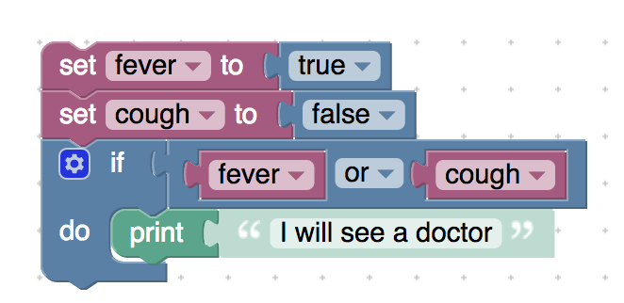

<xml xmlns="http://www.w3.org/1999/xhtml">

 <variables>

    <variable type="" id="X;zy$/hx4e}t*6k2H.9L">fever</variable>

    <variable type="" id="a2tx1ho;an]p{=ya?YuV">cough</variable>

 </variables>

 <block type="variables_set" id="jPji0*)gp(@;u:;Pu,-!" x="313" y="62">

    <field name="VAR" id="X;zy$/hx4e}t*6k2H.9L" variabletype="">fever</field>

    <value name="VALUE">

     <block type="logic_boolean" id="8J8e#xi@r*3e*gkUnoV`">

       <field name="BOOL">TRUE</field>

     </block>

    </value>

    <next>

     <block type="variables_set" id="b5`5~vX%U~5D*ns-`c}Y">

       <field name="VAR" id="a2tx1ho;an]p{=ya?YuV" variabletype="">cough</field>

       <value name="VALUE">

         <block type="logic_boolean" id="=@?qE|v74OjgxOARmPro">

           <field name="BOOL">FALSE</field>

         </block>

       </value>

       <next>

         <block type="controls_if" id="f/fd_(sN@!xY2a-L8TxV">

           <value name="IF0">

             <block type="logic_operation" id="t;-3_C=x+OLx_?zR9/ER">

               <field name="OP">OR</field>

               <value name="A">

                 <block type="variables_get" id="JCvsSq`M|q@1ORv-1!Eq">

                   <field name="VAR" id="X;zy$/hx4e}t*6k2H.9L" variabletype="">fever</field>

                 </block>

               </value>

               <value name="B">

                 <block type="variables_get" id=":H|7NueN}A^)u{}k4SK5">

                   <field name="VAR" id="a2tx1ho;an]p{=ya?YuV" variabletype="">cough</field>

                 </block>

               </value>

             </block>

           </value>

           <statement name="DO0">

             <block type="text_print" id="N5b9b{|jB=HHJQGBZYVe">

               <value name="TEXT">

                 <shadow type="text" id="?ao|77r9r|0OSJ@VyDoB">

                   <field name="TEXT">I will see a doctor</field>

                 </shadow>

               </value>

             </block>

           </statement>

         </block>

       </next>

     </block>

    </next>

 </block>

</xml>

**Description:** Multiple ORs in 1 if (a or b or c)

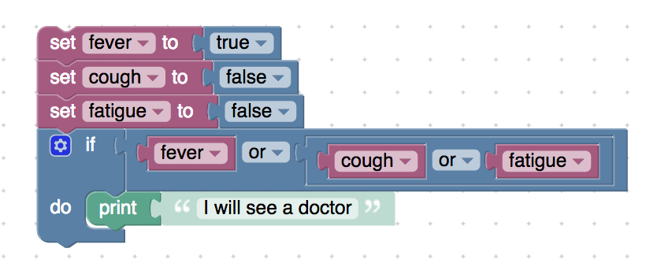

<xml xmlns="http://www.w3.org/1999/xhtml">

 <variables>

    <variable type="" id="X;zy$/hx4e}t*6k2H.9L">fever</variable>

    <variable type="" id="a2tx1ho;an]p{=ya?YuV">cough</variable>

    <variable type="" id="M2P-qEea]xEkO]kg0vSn">fatigue</variable>

 </variables>

 <block type="variables_set" id="jPji0*)gp(@;u:;Pu,-!" x="313" y="62">

    <field name="VAR" id="X;zy$/hx4e}t*6k2H.9L" variabletype="">fever</field>

    <value name="VALUE">

     <block type="logic_boolean" id="8J8e#xi@r*3e*gkUnoV`">

       <field name="BOOL">TRUE</field>

     </block>

    </value>

    <next>

     <block type="variables_set" id="b5`5~vX%U~5D*ns-`c}Y">

       <field name="VAR" id="a2tx1ho;an]p{=ya?YuV" variabletype="">cough</field>

       <value name="VALUE">

         <block type="logic_boolean" id="=@?qE|v74OjgxOARmPro">

           <field name="BOOL">FALSE</field>

         </block>

       </value>

       <next>

         <block type="variables_set" id="+UW/*6.aOl;!^]b:=oIz">

           <field name="VAR" id="M2P-qEea]xEkO]kg0vSn" variabletype="">fatigue</field>

           <value name="VALUE">

             <block type="logic_boolean" id="bNy*k9tS!v1#)c^i$]]-">

               <field name="BOOL">FALSE</field>

             </block>

           </value>

           <next>

             <block type="controls_if" id="f/fd_(sN@!xY2a-L8TxV">

               <value name="IF0">

                 <block type="logic_operation" id="t;-3_C=x+OLx_?zR9/ER">

                   <field name="OP">OR</field>

                   <value name="A">

                     <block type="variables_get" id="JCvsSq`M|q@1ORv-1!Eq">

                       <field name="VAR" id="X;zy$/hx4e}t*6k2H.9L" variabletype="">fever</field>

                     </block>

                   </value>

                   <value name="B">

                     <block type="logic_operation" id="_AFgxuc*d-qEZAEp2{4L">

                       <field name="OP">OR</field>

                       <value name="A">

                         <block type="variables_get" id=":H|7NueN}A^)u{}k4SK5">

                           <field name="VAR" id="a2tx1ho;an]p{=ya?YuV" variabletype="">cough</field>

                         </block>

                       </value>

                       <value name="B">

                         <block type="variables_get" id=")^SY!E/h|VHC;VU%7krb">

                           <field name="VAR" id="M2P-qEea]xEkO]kg0vSn" variabletype="">fatigue</field>

                         </block>

                       </value>

                     </block>

                   </value>

                 </block>

               </value>

               <statement name="DO0">

                 <block type="text_print" id="N5b9b{|jB=HHJQGBZYVe">

                   <value name="TEXT">

                     <shadow type="text" id="?ao|77r9r|0OSJ@VyDoB">

                       <field name="TEXT">I will see a doctor</field>

                     </shadow>

                   </value>

                 </block>

               </statement>

             </block>

           </next>

         </block>

       </next>

     </block>

    </next>

 </block>

</xml>

**Description:** An example to show how to use not equal to (≠)

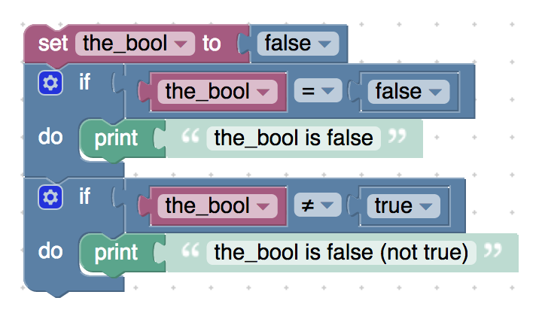

<xml xmlns="http://www.w3.org/1999/xhtml">

 <variables>

    <variable type="" id="r;zSDI~?eb0ody#T./@h">the_bool</variable>

 </variables>

 <block type="variables_set" id="}tD+z(G;~7?EjEzt,i^o" x="63" y="-63">

    <field name="VAR" id="r;zSDI~?eb0ody#T./@h" variabletype="">the_bool</field>

    <value name="VALUE">

     <block type="logic_boolean" id="/c^#f9x#y:M6SS[|]2g1">

       <field name="BOOL">FALSE</field>

     </block>

    </value>

    <next>

     <block type="controls_if" id="/2T7MzG+;W;@SgqLD6f=">

       <value name="IF0">

         <block type="logic_compare" id="ST^Pj$}AB1d=#cUw?,w}">

           <field name="OP">EQ</field>

           <value name="A">

             <block type="variables_get" id="VM8Og);-0M#T444gipD$">

               <field name="VAR" id="r;zSDI~?eb0ody#T./@h" variabletype="">the_bool</field>

             </block>

           </value>

           <value name="B">

             <block type="logic_boolean" id="Vt2T81m9HH;gUtZo7?Co">

               <field name="BOOL">FALSE</field>

             </block>

           </value>

         </block>

       </value>

       <statement name="DO0">

         <block type="text_print" id="5/C(5:b;A^8SrW5+kZSm">

           <value name="TEXT">

             <shadow type="text" id="7tB4AS_2{RopUC#nMa@b">

               <field name="TEXT">the_bool is false</field>

             </shadow>

           </value>

         </block>

       </statement>

       <next>

         <block type="controls_if" id="j$lfJ`.i8[RhJNp2a#5#">

           <value name="IF0">

             <block type="logic_compare" id="{jJ!:xGXf@i4n3jUsuj~">

               <field name="OP">NEQ</field>

               <value name="A">

                 <block type="variables_get" id="(n{!Zxw{|,$Pn|kD0U$k">

                   <field name="VAR" id="r;zSDI~?eb0ody#T./@h" variabletype="">the_bool</field>

                 </block>

               </value>

               <value name="B">

                 <block type="logic_boolean" id="M0c|c{cf}wVmN?EGu=.$">

                   <field name="BOOL">TRUE</field>

                 </block>

               </value>

             </block>

           </value>

           <statement name="DO0">

             <block type="text_print" id="6/d3jE=6,8xiBb5d=|Qw">

               <value name="TEXT">

                 <shadow type="text" id="@|QNYn_.jEvt(h~CE(4z">

                   <field name="TEXT">the_bool is false (not true)</field>

                 </shadow>

               </value>

             </block>

           </statement>

         </block>

       </next>

     </block>

    </next>

 </block>

</xml>

**Description:**  An example to show that not false is true

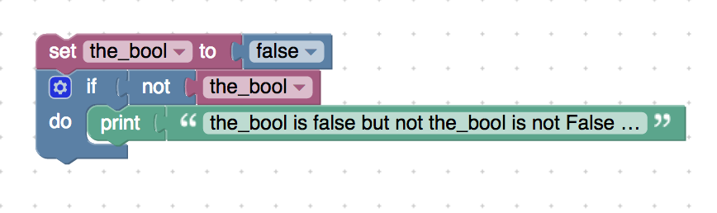

<xml xmlns="http://www.w3.org/1999/xhtml">

 <variables>

    <variable type="" id="r;zSDI~?eb0ody#T./@h">the_bool</variable>

 </variables>

 <block type="variables_set" id="}tD+z(G;~7?EjEzt,i^o" x="113" y="-38">

    <field name="VAR" id="r;zSDI~?eb0ody#T./@h" variabletype="">the_bool</field>

    <value name="VALUE">

     <block type="logic_boolean" id="/c^#f9x#y:M6SS[|]2g1">

       <field name="BOOL">FALSE</field>

     </block>

    </value>

    <next>

     <block type="controls_if" id="j$lfJ`.i8[RhJNp2a#5#">

       <value name="IF0">

         <block type="logic_negate" id="W[|nXEX!Q,-OD|o+iFOc">

           <value name="BOOL">

             <block type="variables_get" id="4]OkU]xc!_Ivc.fkk[2M">

               <field name="VAR" id="r;zSDI~?eb0ody#T./@h" variabletype="">the_bool</field>

             </block>

           </value>

         </block>

       </value>

       <statement name="DO0">

         <block type="text_print" id="6/d3jE=6,8xiBb5d=|Qw">

           <value name="TEXT">

             <shadow type="text" id="@|QNYn_.jEvt(h~CE(4z">

               <field name="TEXT">the_bool is false but not the_bool is not False (True)</field>

             </shadow>

             <block type="text" id="j0Ic$QB%;y44_t7#NIsW">

               <field name="TEXT">the_bool is false but not the_bool is not False (True)</field>

             </block>

           </value>

         </block>

       </statement>

     </block>

    </next>

 </block>

</xml>

**Description:** An example to show that “not None” is True

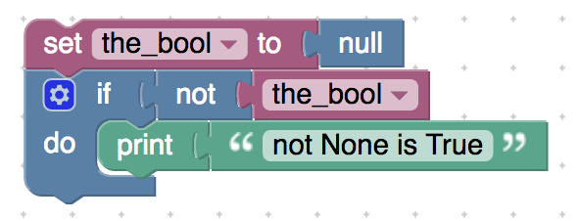

<xml xmlns="http://www.w3.org/1999/xhtml">

 <variables>

    <variable type="" id="r;zSDI~?eb0ody#T./@h">the_bool</variable>

 </variables>

 <block type="variables_set" id="}tD+z(G;~7?EjEzt,i^o" x="263" y="-13">

    <field name="VAR" id="r;zSDI~?eb0ody#T./@h" variabletype="">the_bool</field>

    <value name="VALUE">

     <block type="logic_null" id=";]TrzFLql%AsE#~jE0Mr"></block>

    </value>

    <next>

     <block type="controls_if" id="j$lfJ`.i8[RhJNp2a#5#">

       <value name="IF0">

         <block type="logic_negate" id="mvVX:/!23s`oh7zt)EAM">

           <value name="BOOL">

             <block type="variables_get" id="36yn+2a*v;aw:{c|#]H^">

               <field name="VAR" id="r;zSDI~?eb0ody#T./@h" variabletype="">the_bool</field>

             </block>

           </value>

         </block>

       </value>

       <statement name="DO0">

         <block type="text_print" id="6/d3jE=6,8xiBb5d=|Qw">

           <value name="TEXT">

             <shadow type="text" id="@|QNYn_.jEvt(h~CE(4z">

               <field name="TEXT">the_bool is false but not the_bool is not False (True)</field>

             </shadow>

             <block type="text" id="j0Ic$QB%;y44_t7#NIsW">

               <field name="TEXT">not None is True</field>

             </block>

           </value>

         </block>

       </statement>

     </block>

    </next>

 </block>

</xml>